**Sports Management System**



Index

|  |  |  |
| --- | --- | --- |
| Sr. No | Content | Page No |
| 1 | Introduction | 3 |
| 2 | Functional Requirement | 4 |
| 3 | ER Diagram | 5 |
| 4 | Database Tables | 6 |
| 5 | Data Definition Language | 12 |
| 6 | Data Manipulation Language | 20 |
| 7 | Bibliography | 33 |

Introduction

Team sports are very popular, especially among kids and teens.In recent years, there’s been a huge increase in organized sports for kids and young adults. This has given rise to sports schools: places where enthusiasts of team sports can go to sharpen their skills and improve their physical fitness.

The Sports Management System (SMS) objective is to provide which manages the activity of many sports at a time. It also manages the daily batches, coach details, players personal details, practice sessions, equipment details, courts details.

There are two users players and the management staff.Management staff includes coach, receptionist, inventory\_manager.

Coaches can view the players profile, assign a player to a team, teach the sports ,also take practice session of the team on given time table, request an equipment, book/cancel/reschedule the court/ request new equipment.Players can see the practice time table, make payments, make requests (e.g. change in team). The management staff will keep track of coach attendance, record of equipment ,see and manage requests raised by players/ coach.

**Functional Requirements**

Sports Management System:

Player:

* Player can register into system.
* Player can insert the personal information
* Player can view the offers
* Player can make payment
* Player can upload ID proofs
* Player can update their profile.
* Player can see the practice time tables
* Player can view their attendance
* Player can raise a request to change the team.

Coach:

* Coach can login into the system
* Coach can view the players details
* Coach can view their attendance
* Coach can view player’s attendance
* Coach can request an equipment
* Coach can book/cancel/reschedule the court
* Coach can raise a request for new equipment
* Coach can schedule the practices of teams

Receptionist:

* Receptionist can login into the system
* Receptionist can check the players personal details
* Receptionist can check the available batches
* Receptionist can check ongoing offers

Inventory\_manager

* Inventory\_manager can check the equipment details
* Inventory\_manager can check the equipment orders
* Inventory\_manager can check the equipment usages.

ER Diagram

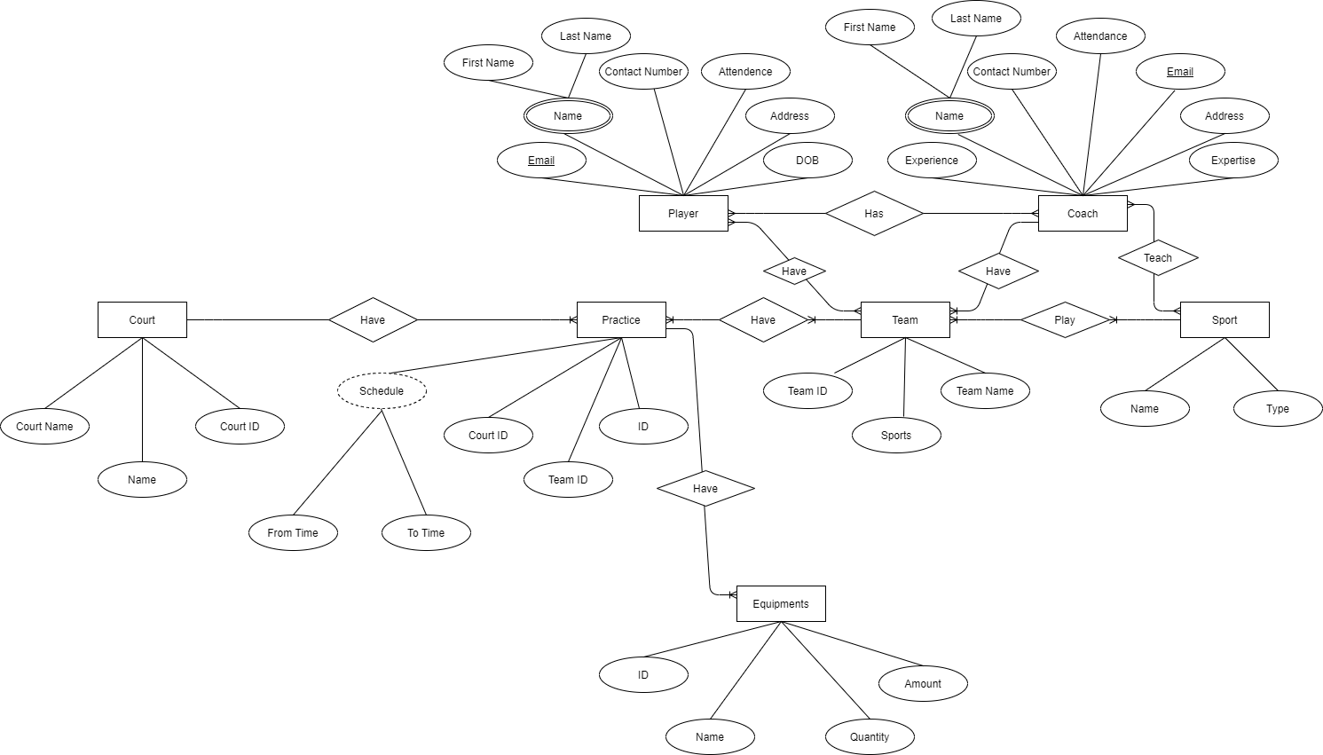

Database Tables

|  |  |  |  |
| --- | --- | --- | --- |
| **Login** | | | |
| Field Name | Data Type | Key/ Constraint | Description |
| email | varchar | PK | user email id |
| password | varchar |  | account password |
| user Type | enum |  | user type (player/employee) |
| Is\_active | boolean |  | Is user account active? |

|  |  |  |  |
| --- | --- | --- | --- |
| **Player\_Personal\_Details** | | | |
| Field Name | Data Type | Key/ Constraint | Description |
| PlayerID | int | PK | Player ID |
| First Name | varchar |  | Player First Name |
| Last Name | varchar |  | Player last name |
| Gender | Enum |  | Gender |
| email | varchar | FK , Unique | Player registered email id |
| address | varchar |  | Address |
| ID | varchar |  | Player ID path |
| DOB | Date |  | Date of birth |
| Membership\_type | Enum |  | Membership type |
| Joining\_date | Date |  | Joining date |

|  |  |  |  |
| --- | --- | --- | --- |
| **Employee\_details** | | | |
| Field Name | Data Type | Key/ Constraint | Description |
| emp\_id | int | PK | employee id |
| First Name | Varchar |  | First name |
| Last Name | Varchar |  | Last name |
| department | Enum |  | employee's department |
| Expertise | varchar |  | employee's expertise |
| salary | float |  | salary per month |
| Joining\_date | Date |  | Joining date |
| Email | Varchar | FK | Employee email ID |

|  |  |  |  |
| --- | --- | --- | --- |
| **Court booking details** | | | |
| Field Name | Data Type | Key/ Constraint | Description |
| booking id | int | PK | booking id |
| court id | int | FK | court id |
| from date | date |  | from date |
| to date | date |  | to date |
| from time | timestamp |  | from time |
| to time | timestamp |  | till time |

|  |  |  |  |
| --- | --- | --- | --- |
| **Court details** | | | |
| Field Name | Data Type | Key/ Constraint | Description |
| court id | int | PK | court id |
| court name | varchar |  | court name |
| length | float |  | court length |
| width | float |  | court width |

|  |  |  |  |
| --- | --- | --- | --- |
| **Employee absence details** | | | |
| Field Name | Data Type | Key/ Constraint | Description |
| id | int | pk | absence id |
| emp\_id | int | Fk | employee id |
| from | date |  | from date |
| to | date |  | to date |
| Reason | varchar |  | reason |

|  |  |  |  |
| --- | --- | --- | --- |
| **Employee complaints** | | | |
| Field Name | Data Type | Key/ Constraint | Description |
| id | int | PK | complaint id |
| created by | int | FK | employee id |
| assigned to | int | FK | employee id |
| created on | date |  | created date |
| description | varchar |  | description |
| Priority | enum |  | priority |
| Status | enum |  | status |
| updated\_on | timestamp |  | updated timestamp |

|  |  |  |  |
| --- | --- | --- | --- |
| **Employee order request** | | | |
| Field Name | Data Type | Key/ Constraint | Description |
| id | int | PK | request id |
| created by | int | FK | employee id |
| assigned to | int | FK | employee id |
| created on | date |  | created date |
| description | varchar |  | description |
| Priority | enum |  | priority |
| Status | enum |  | status |
| updated\_on | timestamp |  | updated timestamp |
| dead line | date |  | dead line |

|  |  |  |  |
| --- | --- | --- | --- |
| **Equipment** | | | |
| Field Name | Data Type | Key/ Constraint | Description |
| id | int | pk | equipment id |
| name | varchar |  | equipment name |
| equipment\_set | int | Fk | equipment fk |
| quantity | int |  | equipment quantity |
| realted\_sports | varchar |  | sports |

|  |  |  |  |
| --- | --- | --- | --- |
| **Equipment Order** | | | |
| Field Name | Data Type | Key/ Constraint | Description |
| id | int | pk | Order id |
| equipment id | int | fk | equipment id |
| placed by | int | fk | emp id |
| placed date | date |  | placed date |
| quantity | int |  | equipment quantity |
| amount | float |  | amount per item |
| total amount | float |  | total amount |
| status | enum |  | status |
| is\_completed | boolean |  | if order is completed |
| Updated\_on | timestamp |  | Updated date |

|  |  |  |  |
| --- | --- | --- | --- |
| **Equipment Set** | | | |
| Field Name | Data Type | Key/ Constraint | Description |
| set id | int | pk | set Id |
| description | varchar |  | set description |
| sport name | varchar | fk | sport name |
| available set | int |  | number of available set |
| total set | int |  | number of total set |

|  |  |  |  |
| --- | --- | --- | --- |
| **Equipment Usage** | | | |
| Field Name | Data Type | Key/ Constraint | Description |
| coach id | int | pk | coach Id |
| set id | int | fk | set id |
| from | date |  | from date |
| to | date |  | to date |
| from time | timestamp |  | from time |
| to time | timestamp |  | to time |
| number\_of\_sets | int |  | number of required sets |

|  |  |  |  |
| --- | --- | --- | --- |
| **Membership details** | | | |
| Field Name | Data Type | Key/ Constraint | Description |
| name | varchar | pk | Membership name |
| description | varchar |  | Membership description |

|  |  |  |  |
| --- | --- | --- | --- |
| **Offer details** | | | |
| Field Name | Data Type | Key/ Constraint | Description |
| offer\_id | int | pk | offer id |
| description | varchar |  | offer description |
| valid from | date |  | valid from date |
| valid to | date |  | valid till date |
| is\_valid | boolean |  | is offer valid |

|  |  |  |  |
| --- | --- | --- | --- |
| **Payment** | | | |
| Field Name | Data Type | Key/ Constraint | Description |
| payment\_id | int | pk | payment id |
| player\_id | int | fk | player id |
| total amount | float |  | total amount |
| paid amount | float |  | paid amount |
| remaining amount | float |  | remaining amount |
| is\_offer\_applied | boolean |  | is offer applied |
| offer\_id | int |  | offer id |
| status | enum |  | payment status |
| amount after offer | float |  | amount after offer applied |
| updated\_on | date |  | updated on |

|  |  |  |  |
| --- | --- | --- | --- |
| **Player\_change\_request** | | | |
| Field Name | Data Type | Key/ Constraint | Description |
| request\_id | int | Pk | request id |
| created by | int | fk | created by emp id |
| created date | date |  | created date |
| dead line | date |  | dead line date |
| description | varchar |  | change request description |
| priority | enum |  | request priority |
| updated\_on | timestamp |  | Updated on |

|  |  |  |  |
| --- | --- | --- | --- |
| **Player absence details** | | | |
| Field Name | Data Type | Key/ Constraint | Description |
| absent id | int | Pk | absent id |
| player id | int | fk | player id |
| from | date |  | from date |
| to | date |  | to date |
| reason | varchar |  | reason |
| practice id | int | fk | practice id |

|  |  |  |  |
| --- | --- | --- | --- |
| **Sports** | | | |
| Field Name | Data Type | Key/ Constraint | Description |
| name | varchar | pk | sport name |
| type | enum |  | sport type |

|  |  |  |  |
| --- | --- | --- | --- |
| **Team Assignment** | | | |
| Field Name | Data Type | Key/ Constraint | Description |
| team id | int | fk | team id |
| player id | int | fk | player id |

|  |  |  |  |
| --- | --- | --- | --- |
| **Practice** | | | |
| Field Name | Data Type | Key/ Constraint | Description |
| Practice\_id | int | Pk | practice id |
| date | date |  | Practice date |
| team id | int | fk | team id |
| from time | timestamp |  | from time |
| to time | timestamp |  | till time |
| court booking id | int | fk | court booking id |
| updated on | timestamp |  | updated on |
| status | enum |  | status |

|  |  |  |  |
| --- | --- | --- | --- |
| **Team Details** | | | |
| Field Name | Data Type | Key/ Constraint | Description |
| team id | int | pk | team id |
| coach id | int | fk | coach id |
| team name | varchar |  | team name |
| total positions | int |  | total position in team |
| occupied position | int |  | occupied postilions |
| remaining position | int |  | remaining positions |
| sport | varchar | fk | sport |

**Data Definition Language**

**Create table queries**

create table login(email varchar(50), password varchar(30),userType enum("Player", "Employee") not null, PRIMARY key(email))

create table employee\_details (emp\_id int not null AUTO\_INCREMENT, fname varchar(20), lname varchar(20), email varchar(50) not null, contact bigint not null,department enum("Coaching, Enquiry,Inventory"),salary int, joining\_date date not null,PRIMARY key (emp\_id), FOREIGN key (email) REFERENCES login(email))

create table team\_details(team\_id int not null AUTO\_INCREMENT,team\_name varchar(30), sports\_specification enum("Tennis","Kabaddi","Football","Bascketball","Chess","Swimming","Badminton","Cricket","Badminton","Running","Boxing","Karate","kickboxing") not null, PRIMARY key (team\_id))

create table player\_personal\_details(player\_id int not null AUTO\_INCREMENT, fname varchar(20), lname varchar(20), email varchar(50), contact bigint not null,dob date,address varchar(200), photo\_ID varchar(200) not null, PRIMARY key (player\_id), FOREIGN key (email) REFERENCES login(email))

create table team\_assignment(player\_id int not null , team\_id int not null, FOREIGN key (team\_id) REFERENCES team\_details(team\_id), FOREIGN key (player\_id) REFERENCES player\_personal\_details(player\_id))

create table payment(payment\_id int not null AUTO\_INCREMENT,player\_id int not null,total\_amount float, remaining\_amount float,status enum("Not Paid","Paid","In-Installments") not null,updated\_on timestamp DEFAULT CURRENT\_TIMESTAMP(),PRIMARY key(payment\_id), FOREIGN key(player\_id) REFERENCES player\_personal\_details (player\_id))

create table court\_details( court\_id int not null AUTO\_INCREMENT, court\_name varchar(50) not null, length float not null, width float not null,primary key(court\_id))

create table practice(practice\_id int not null AUTO\_INCREMENT, practice\_date date, from\_time time, till\_time time, court\_id int not null, status enum("Confirmed","Canceled","Rescheduled"),team\_id int not null,updated\_on timestamp default CURRENT\_TIMESTAMP, PRIMARY key(practice\_id), FOREIGN key(team\_id) REFERENCES team\_details(team\_id), FOREIGN key(court\_id) REFERENCES court\_details(court\_id))

create table player\_attendance(attendance\_id int not null AUTO\_INCREMENT, attendace\_date date,player\_id int not null, practice\_id int not null, attendence enum("Present","Absent"), PRIMARY key(attendance\_id), FOREIGN key(player\_id) REFERENCES player\_personal\_details(player\_id), FOREIGN key(practice\_id) REFERENCES practice(practice\_id))

create table employee\_attendace(emp\_attendance\_id int not null AUTO\_INCREMENT, attendance\_date date, emp\_id int not null,attendance enum("Present","Absent"), PRIMARY key(emp\_attendance\_id), FOREIGN key (emp\_id) REFERENCES employee\_details(emp\_id))

create table equipment\_type(equipment\_id int not null AUTO\_INCREMENT, name varchar(30), PRIMARY key(equipment\_id))

create table sports(sport\_name varchar(50) not null)

create table equipment\_order(order\_id int not null AUTO\_INCREMENT, equipment\_id int not null, amount\_per float , quantity float, status enum("Placed","Cancelled","Delivered"),placed\_by int not null,placed\_date date default CURRENT\_DATE, is\_completed boolean default false, PRIMARY key(order\_id), FOREIGN key(equipment\_id) REFERENCES equipment(equipment\_id), FOREIGN key (placed\_by) REFERENCES employee\_details(emp\_id), updated\_on timestamp default CURRENT\_TIMESTAMP)

create table equipment\_usage(equipment\_id int not null , coach\_id int not null, from\_date date default CURRENT\_DATE, to\_date date default null, from\_time time , to\_time time, FOREIGN key(equipment\_id) REFERENCES equipment(equipment\_id),FOREIGN key(coach\_id) REFERENCES employee\_details(emp\_id))

create table players\_change\_request(request\_id int not null AUTO\_INCREMENT, created\_by int not null, description varchar(2000), priority enum("P1","P2","P3"),assigned\_to int, dead\_line date, status enum ("Created","Assigned","In-Progess","Completed", "Rejected", "Closed") DEFAULT "Created", created\_date date default CURRENT\_DATE, updated\_on timestamp DEFAULT CURRENT\_TIMESTAMP, PRIMARY key(request\_id), FOREIGN key(created\_by) REFERENCES player\_personal\_details (player\_id),FOREIGN key(assigned\_to) REFERENCES employee\_details(emp\_id))

create table employee\_change\_request(request\_id int not null AUTO\_INCREMENT, created\_by int not null, description varchar(2000), priority enum("P1","P2","P3"),assigned\_to int, dead\_line date, status enum ("Created","Assigned","In-Progess","Completed", "Rejected", "Closed") DEFAULT "Created", created\_date date default CURRENT\_DATE, updated\_on timestamp DEFAULT CURRENT\_TIMESTAMP, PRIMARY key(request\_id), FOREIGN key(created\_by) REFERENCES employee\_details (emp\_id),FOREIGN key(assigned\_to) REFERENCES employee\_details(emp\_id))

create table player\_complaints(complaint\_id int not null AUTO\_INCREMENT, description varchar(2000), priority enum("P1","P2","P3"),status enum("Created","Assigned","In-Progress","Resolved","Rejected","Closed") default "Created",created\_by int not null, created\_date date default CURRENT\_DATE, primary key(complaint\_id), FOREIGN key(created\_by) REFERENCES player\_personal\_details(player\_id))

create table offer\_details(offer\_id int not null AUTO\_INCREMENT, offer\_description varchar(2000) not null, valid\_from date not null, valid\_till date not null, PRIMARY key(offer\_id))

create table employee\_complaints(complaint\_id int not null AUTO\_INCREMENT,created\_by int not null, assigned\_to int not null,description varchar(500),priority enum("P1","P2","P3"), created\_on date DEFAULT CURRENT\_DATE,stauts enum("Created","Assigned","Resolved","Rejected","Closed"),updated\_on date default CURRENT\_TIMESTAMP, PRIMARY key (complaint\_id),FOREIGN key(assigned\_to) REFERENCES employee\_details(emp\_id),FOREIGN key(created\_by) REFERENCES employee\_details(emp\_id))

create table equipment\_set (set\_id int not null AUTO\_INCREMENT,set\_description varchar(200), sport\_name varchar(40), PRIMARY key(set\_id), FOREIGN key (sport\_name) REFERENCES sports (sport\_name))

create table membership\_details (membership\_name varchar(50) not null, membership\_description varchar(500), primary key(membership\_name))

**Alter queries**

alter table team\_details add column totalPlayer int not null, accoupied\_position int not null , remaining\_position int not null

alter table batch\_details change team\_id batch\_id int not null AUTO\_INCREMENT

alter table team\_details add CONSTRAINT fk\_coach\_id FOREIGN key (coach\_id) REFERENCES employee\_details(emp\_id)

alter table player\_personal\_details add column joining\_date date

alter table sports add column sport\_type enum ("Single","Multi-Player") not null

alter table team\_details add CONSTRAINT sports\_fk FOREIGN key (sports\_specification) REFERENCES sports (sport\_name)

alter table payment add column is\_offer\_applied enum ("Y","N") default "N"

alter table employee\_details modify column department enum("Choaching","Enquiry","Inventory","Management")

[alter](http://localhost/phpmyadmin/url.php?url=https://dev.mysql.com/doc/refman/5.5/en/alter-table.html" \t "http://localhost/phpmyadmin/mysql_doc) [table](http://localhost/phpmyadmin/url.php?url=https://dev.mysql.com/doc/refman/5.5/en/alter-table.html" \t "http://localhost/phpmyadmin/mysql_doc) equipment\_usage add column num\_of\_sets [int](http://localhost/phpmyadmin/url.php?url=https://dev.mysql.com/doc/refman/5.5/en/numeric-types.html" \t "http://localhost/phpmyadmin/mysql_doc) [not](http://localhost/phpmyadmin/url.php?url=https://dev.mysql.com/doc/refman/5.5/en/logical-operators.html" \l "operator_not" \t "http://localhost/phpmyadmin/mysql_doc) null [default](http://localhost/phpmyadmin/url.php?url=https://dev.mysql.com/doc/refman/5.5/en/miscellaneous-functions.html" \l "function_default" \t "http://localhost/phpmyadmin/mysql_doc) 1

alter table player\_personal\_details add column membership\_end\_date date default Adddate(joining\_date, interval 1 year)

**Add any constraint**

ALTER TABLE login ADD CONSTRAINT passwordLengthChk CHECK (char\_length(password) > 7);

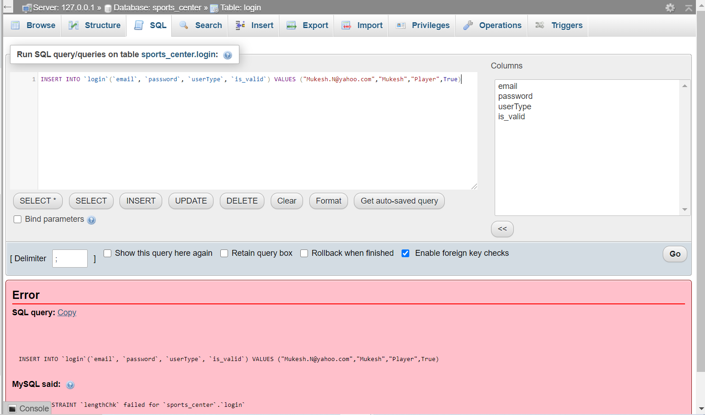

alter table player\_personal\_details add CONSTRAINT UNIQUE (email)

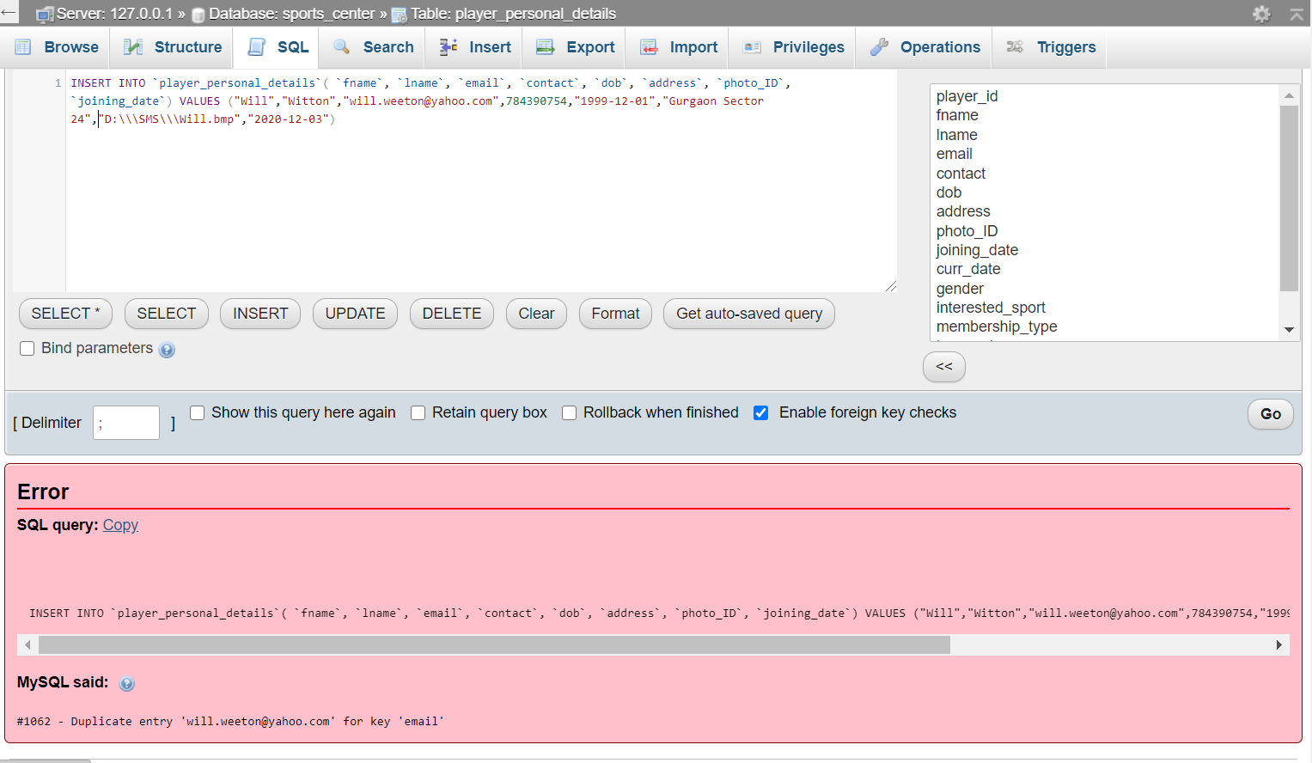

alter table employee\_details add CONSTRAINT UNIQUE (email)

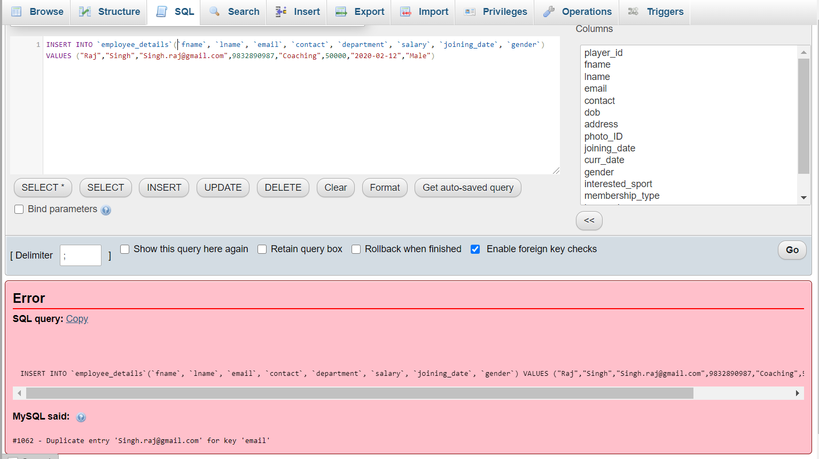

alter table players\_change\_request add CONSTRAINT deadline\_greater\_than\_created\_date CHECK (created\_date <dead\_line )

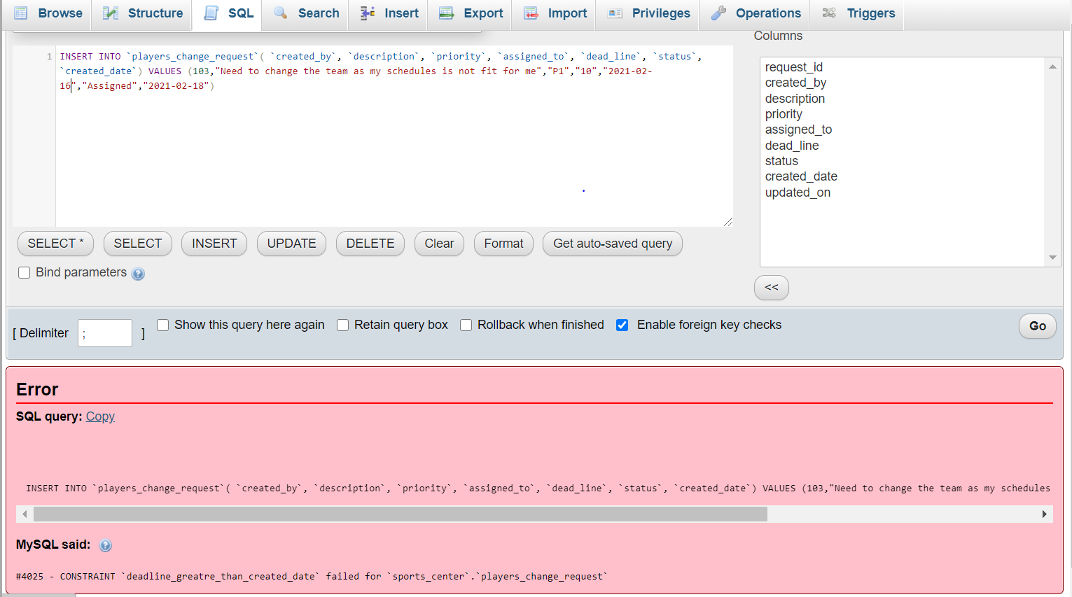

**Data Manipulation Language**

***Insert queries***

INSERT INTO `sports`(`sport\_name`, `sport\_type`) VALUES ("Basketball","multi-player"),("Running","Single"),("Chess","multi-player"),("Football","multi-player"),("Kabaddi","multi-player"),("Karate","multi-player"),("Cricket","Single"),("","multi-player"),("Badminton","multi-player"),("Boxing","multiplayer")

INSERT INTO `court\_details`(`court\_name`, `length`, `width`) VALUES ("Badminton Court",13.4,6.1),("Badminton Court",13.4,6.1),("Bascketball Court",28.7,15.2),("Boxing",4.9,6.1),("Football Ground",65,45),("Running ground",32,45)

INSERT INTO `login`(`email`, `password`, `userType`) VALUES ("Kabir.lamba@gmail.com","kabir@1234","Player"),("John.M@gmail.com","John@m123","Player"),("Vinit.mahajan@yahoo.com","vinitmahajan","Player"),("Priti.shaha@gmail.com","Shaha@1234","Player"),("Mukesh.khanna@gmail.com","mukeshKhanna","Player"),("Venu.g@yahoo.com","venug@123","Player"),("Suresh.singh@gmail.com","singh@1234","Player"),("will.weeton@yahoo.com","wittonwill","Player"),("Pooja.singh@gmail.com","singhpooja","Player"),("Virat.mehta@gmail.com","viratmehta","Player"),("mahendra1@yahoo.com","1@mahendra","Player"),("Heena.patel@gmail.com","heenapatel","Employee"),("Shweta.g@gmail.com","shweta@1234","Player"),("Abhi.partani@gmail.com","parantani@1234","Employee"),("Sona.mohan@gmail.com","live@1243","Employee"),("Singh.raj@gmail.com","rajasarkar","Employee"),("Giri.S@gmail.com","giri@1234","Employee")

INSERT INTO `player\_personal\_details`( `fname`, `lname`, `email`, `contact`, `dob`, `address`, `photo\_ID`, `joining\_date`) VALUES ("Will","Witton","will.weeton@yahoo.com",784390754,"1999-12-01","Gurgaon Sector 24","D:\\\SMS\\\Will.bmp","2020-12-03")

INSERT INTO `employee\_details`(`emp\_id`, `fname`, `lname`, `email`, `contact`, `department`, `salary`, `joining\_date`, `gender`) VALUES (10,"Raj","Singh","Singh.raj@gmail.com",9832890987,"Coaching",50000,"2020-02-12","Male")

INSERT INTO `employee\_absence\_details`( `absent\_from`, `emp\_id`, `attendance`, `reason`, `absent\_to`) VALUES ("2021-02-09",10,"Absent","Medical Emergency","2021-02-14")

INSERT INTO `employee\_complaints`(`complaint\_id`, `created\_by`, `assigned\_to`, `description`, `priority`, `stauts`) VALUES (1,10,13,"Time management between two match slots needs improvement","P1","Assigned")

INSERT INTO `equipment`(`equipment\_id`, `name`, `related\_sports`) VALUES (1,"Tennis Balls", "Tennis")

INSERT INTO `equipment\_order`(`order\_id`, `equipment\_id`, `amount\_per`, `quantity`, `status`, `placed\_by`, `placed\_date`, `is\_completed`) VALUES (101,5,150, 2,"Placed",14,"2021-02-13","N")

INSERT INTO `equipment\_usage`(`equipment\_id`, `coach\_id`, `from\_date`, `to\_date`, `from\_time`, `to\_time`) VALUES (4,10,"2021-03-11","2021-03-13","10:00","11:00")

INSERT INTO `offer\_details`(`offer\_id`, `offer\_description`, `valid\_from`, `valid\_till`) VALUES (1,"10% offer for new memebr","2021-03-10","2021-03-20")

INSERT INTO `payment`(`payment\_id`, `player\_id`, `total\_amount`, `remaining\_amount`, `status`, `is\_offer\_applied`, `amount\_after\_offer`) VALUES (1,101,5000,0,"Paid","N",5000)

INSERT INTO `payment`(`player\_id`, `total\_amount`, `remaining\_amount`, `status`, `is\_offer\_applied`, `amount\_after\_offer`) VALUES (102,5000,2500,"In-Installment","N",5000)

INSERT INTO `players\_change\_request`(`request\_id`, `created\_by`, `description`, `priority`, `assigned\_to`, `dead\_line`, `status`, `created\_date`) VALUES (1,103,"Need to change the team as my schedules is not fit for me","P1","10",AddDate(created\_date, interval 1 month),"Assigned","2021-02-18")

INSERT INTO `team\_details`(`team\_id`, `team\_name`, `sport`, `totalPlayer`, `accoupied\_position`, `remaining\_position`, `coach\_id`) VALUES (1,"Alpha Team","Tennis",4,2,2,10)

INSERT INTO `team\_assignment`(`player\_id`, `team\_id`) VALUES (107,1)

INSERT INTO `equipment\_set`(`set\_id`, `set\_description`, `sport\_name`) VALUES (1,"Badminton-set each set includes 2 rackets and 2 shuttles","Badminton")

INSERT INTO `membership\_details`(`membership\_name`, `membership\_description`) VALUES ("Bronze","This membership includes facilities access for 3 months from joining date")

***Update queries***

update team\_assignment set team\_id = 2 where player\_id = 112

update player\_personal\_details set membership\_end\_date = AddDate(joining\_date, interval 1 year) where membership\_type = "Platinum"

update player\_personal\_details set membership\_end\_date = AddDate(joining\_date, interval 9 month) where membership\_type = "Gold"

update player\_personal\_details set membership\_end\_date = AddDate(joining\_date, interval 6 month) where membership\_type = "Silver"

update player\_personal\_details set membership\_end\_date = AddDate(joining\_date, interval 3 month) where membership\_type = "Bronze"

***Delete queries***

update offer\_details set is\_valid = false where offer\_id =7

update player\_personal\_details set is\_member = false where player\_id = 102

update employee\_details set is\_employee =false where emp\_id =21

Update login set is\_valid= false where email = “will.witton@gmail.com”

***Select queries***

1. **Display practice schedule which has been canceled**

SELECT \* FROM practice where status= "Canceled"

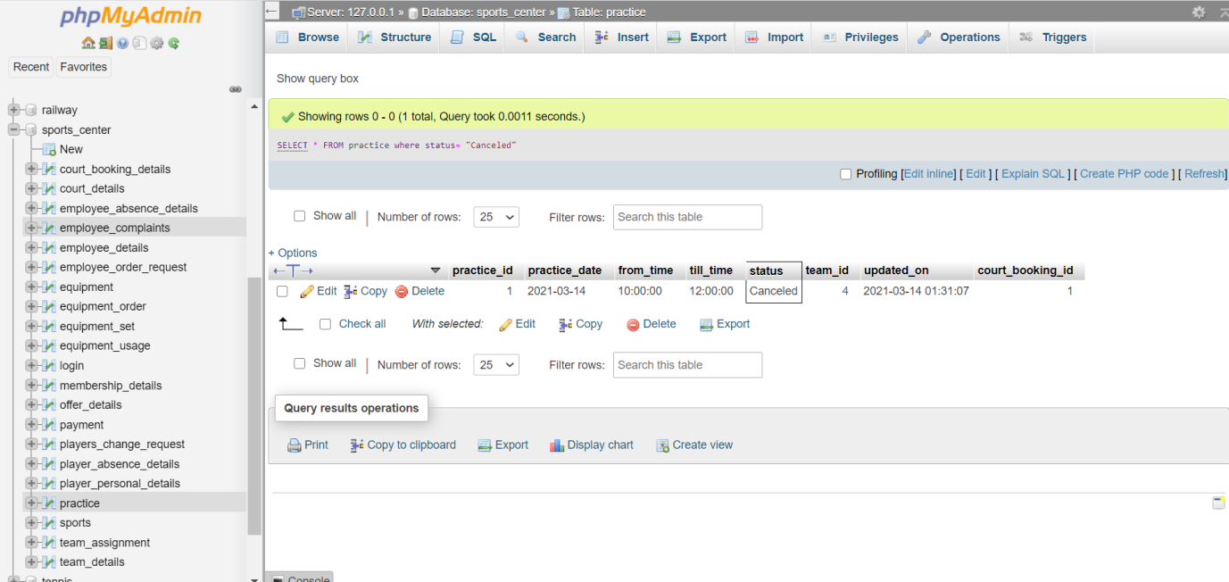

1. **Display the details of players whose practice has been canceled.**

select concat(player\_personal\_details.fname,' ',player\_personal\_details.lname) as name, player\_personal\_details.contact, practice.\* from practice INNER join team\_assignment on practice.team\_id= team\_assignment.team\_id inner join player\_personal\_details on team\_assignment.player\_id= player\_personal\_details.player\_id where practice.status = "Canceled"

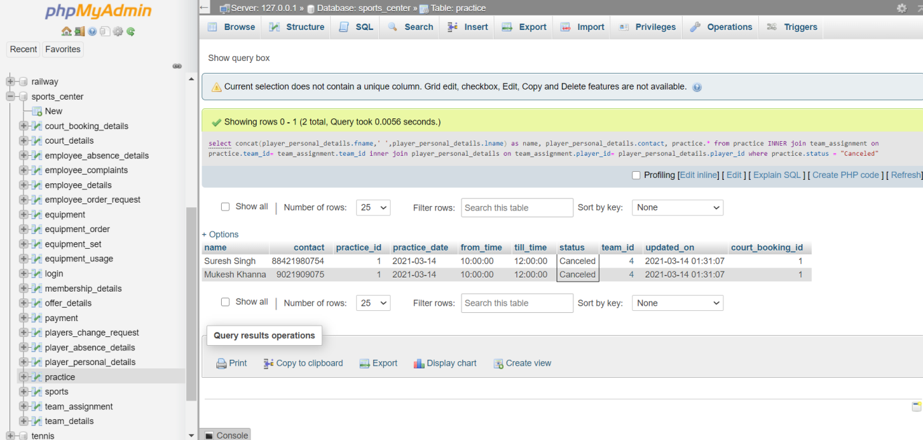

1. **Display the details of players who fees are remaining**

select concat(player\_personal\_details.fname,' ',player\_personal\_details.lname) as name, player\_personal\_details.contact,payment.\* from player\_personal\_details INNER join payment on player\_personal\_details.player\_id=payment.player\_id where payment.remaining\_amount >0

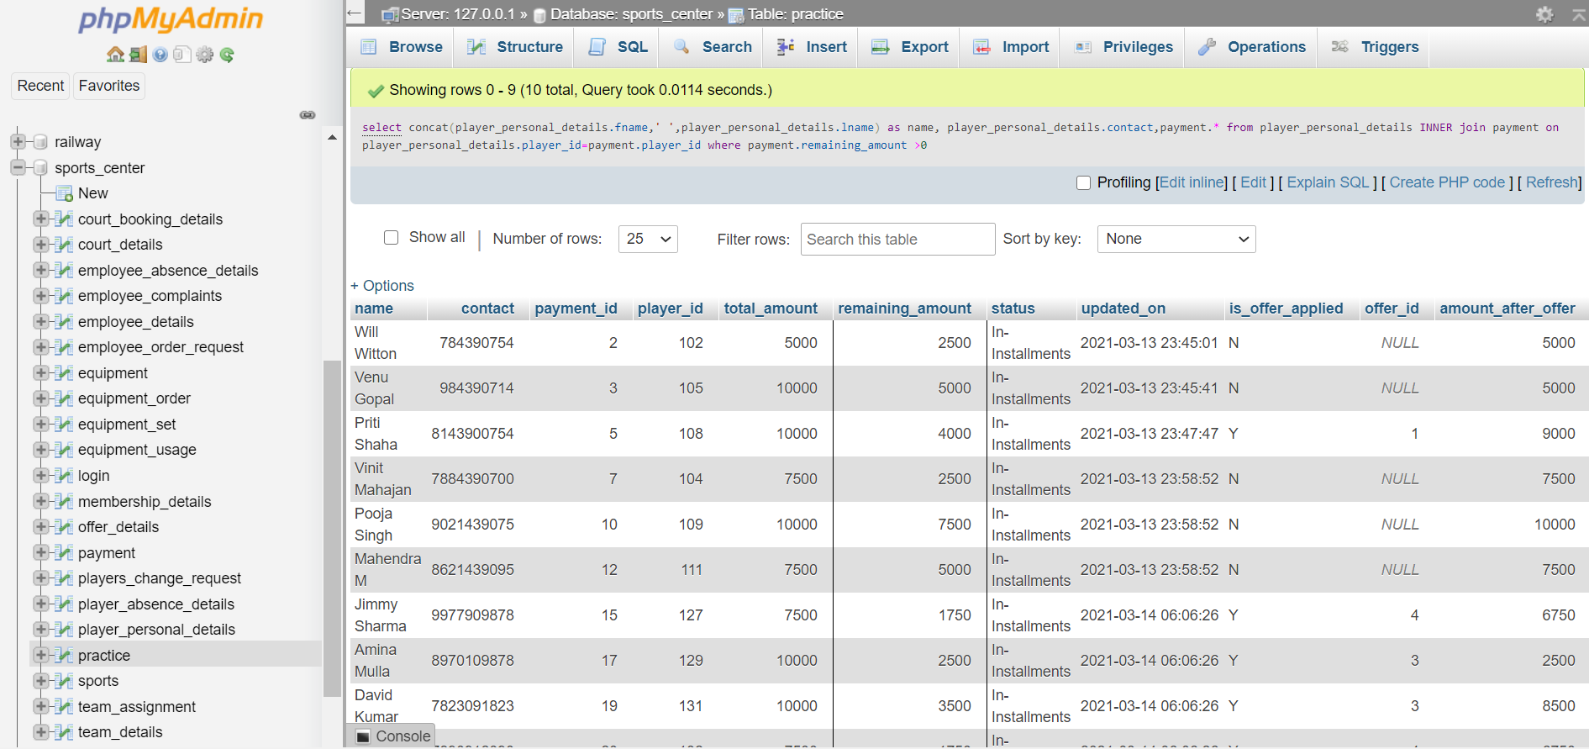

1. **Display the details of valid offers**

select \* from offer\_details where is\_valid = true

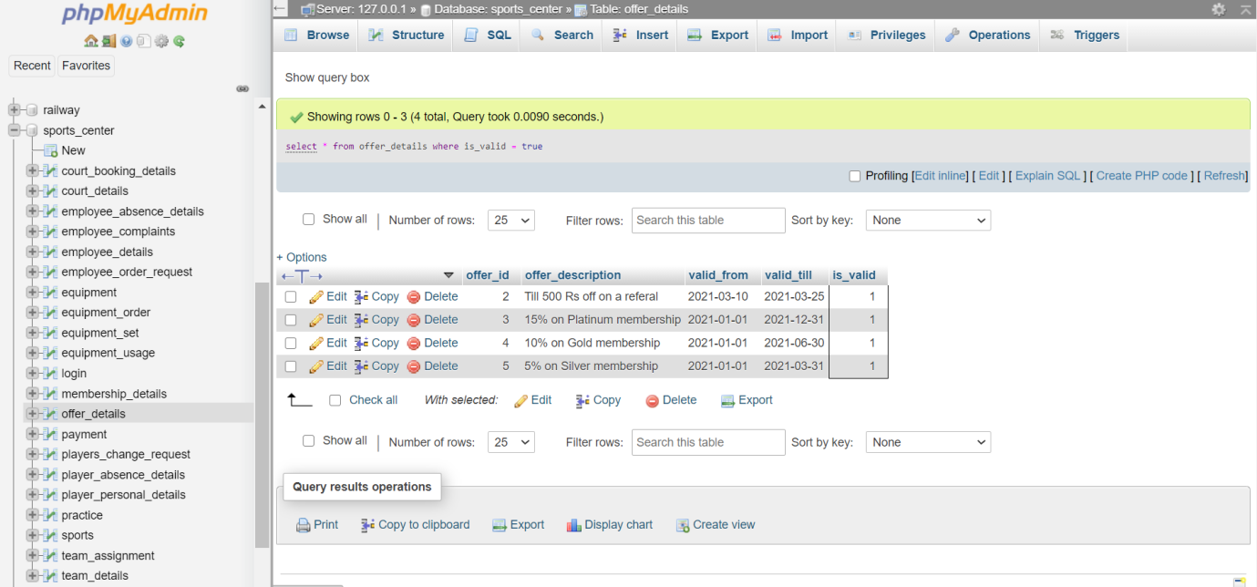

1. **Display details of payment, offer ,player who has platinum membership**

select concat(player\_personal\_details.fname,' ',player\_personal\_details.lname) as name, player\_personal\_details.contact,payment.\*, offer\_details.offer\_description from offer\_details INNER join payment on offer\_details.offer\_id = payment.offer\_id INNER join player\_personal\_details on payment.player\_id=player\_personal\_details.player\_id where player\_personal\_details.membership\_type = "Platinum"

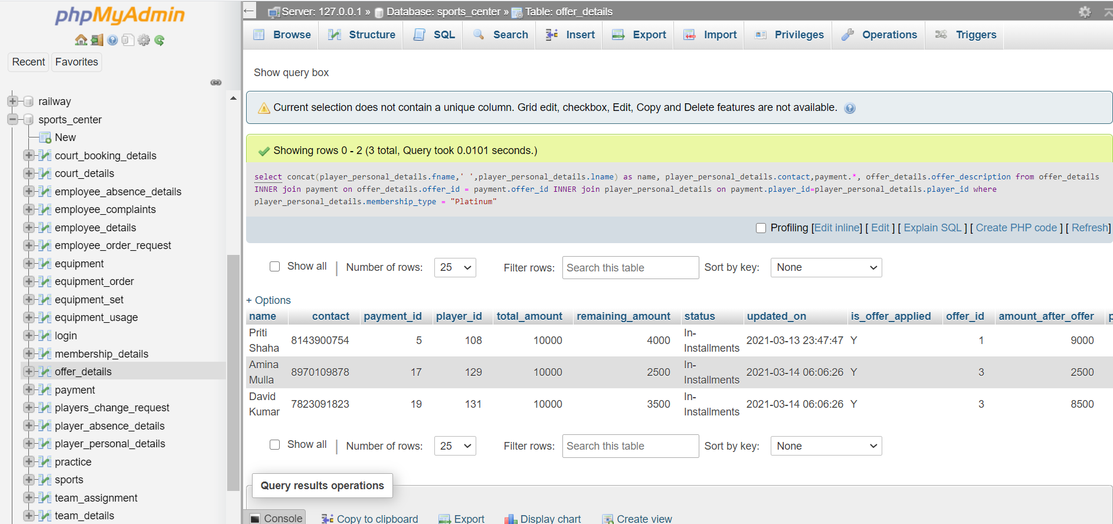

1. **Display the details of players who are no longer member of sports club**

select \* from player\_personal\_details inner join login on player\_personal\_details.email = login.email where login.is\_valid= false

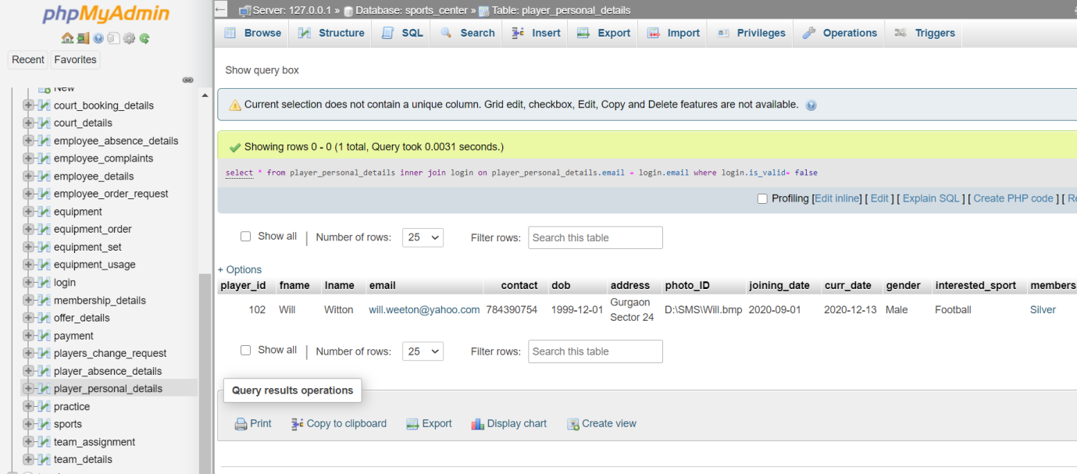

1. **Display the details of players who has practice scheduled for today**

select concat(player\_personal\_details.fname,' ',player\_personal\_details.lname) as name, practice.\* from practice INNER join team\_details on practice.team\_id = team\_details.team\_id INNER join team\_assignment on team\_assignment.team\_id=team\_details.team\_id INNER join player\_personal\_details on team\_assignment.player\_id = player\_personal\_details.player\_id where practice.practice\_date = CURRENT\_DATE

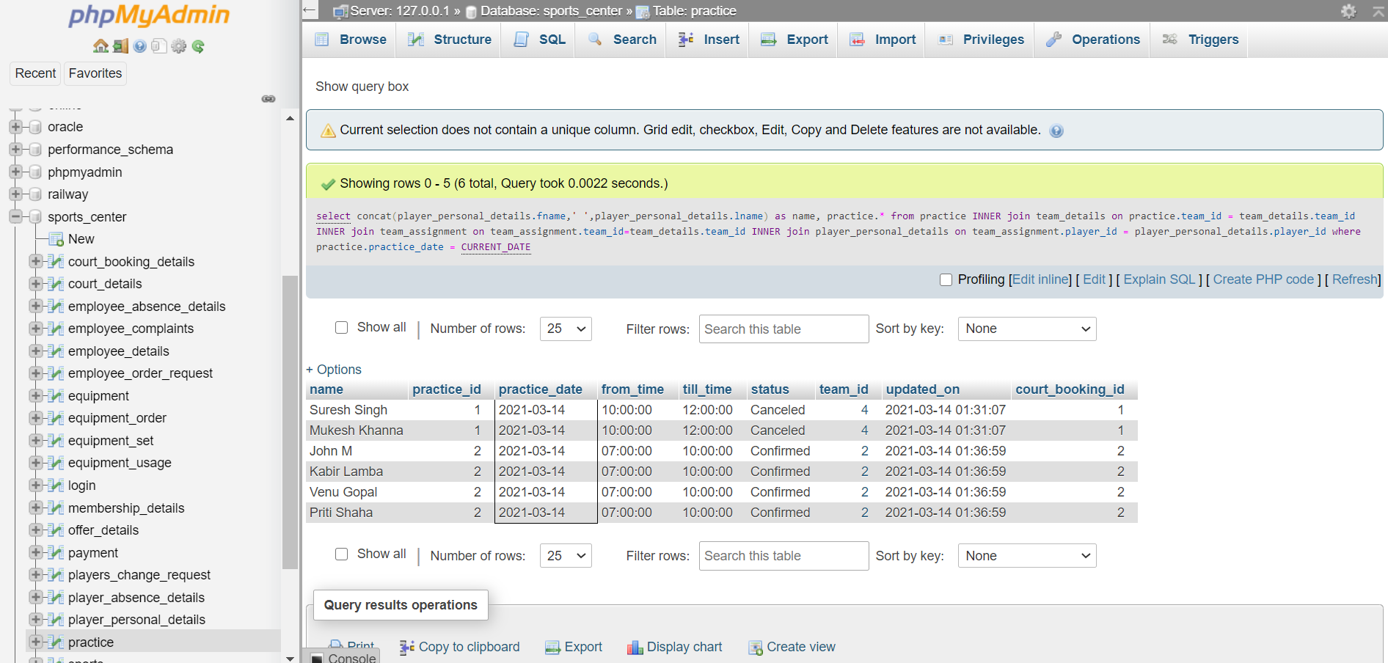

1. **Display the details of coach who is handling more than one team**

select concat(employee\_details.fname,' ',employee\_details.lname) as coachName,employee\_details.department,employee\_details.expertise,count(team\_details.team\_id) as teamsCount from employee\_details INNER join team\_details on team\_details.coach\_id=employee\_details.emp\_id group by team\_details.coach\_id having teamsCount>1

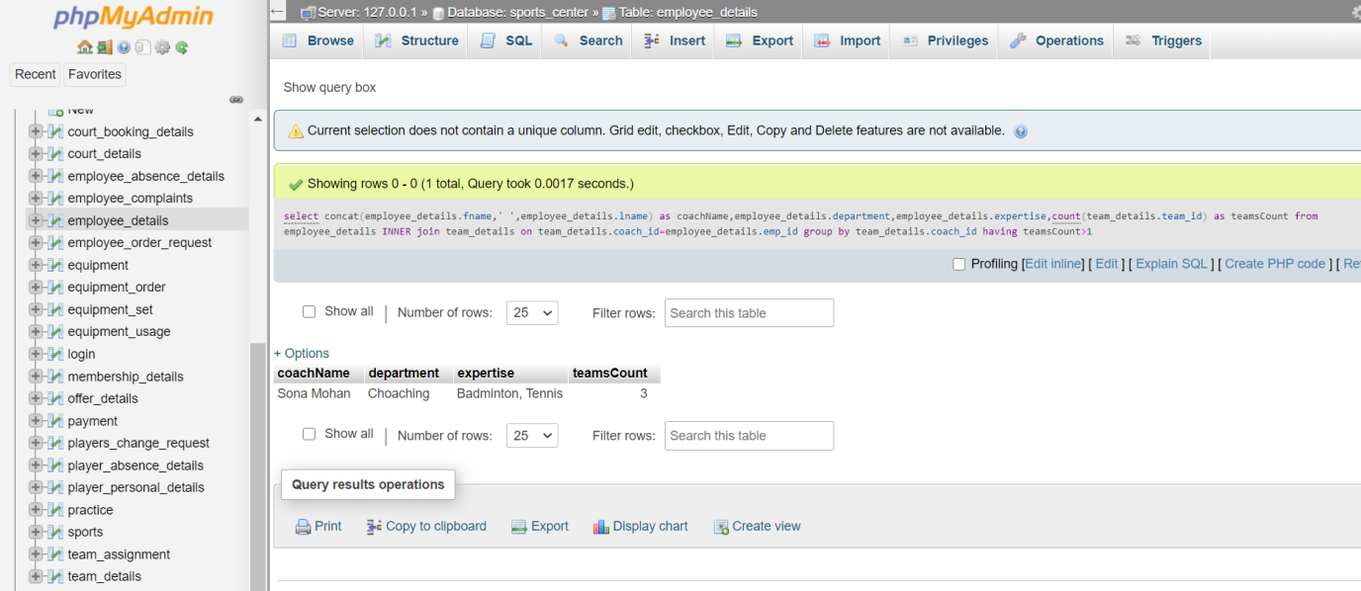

1. **Display the details of coach who is teaching more than one sport**

select concat(employee\_details.fname,' ',employee\_details.lname) as coachName,employee\_details.department,employee\_details.expertise,count(DISTINCT(team\_details.sport)) as sportsCount from employee\_details INNER join team\_details on team\_details.coach\_id=employee\_details.emp\_id GROUP by team\_details.coach\_id having sportsCount>1

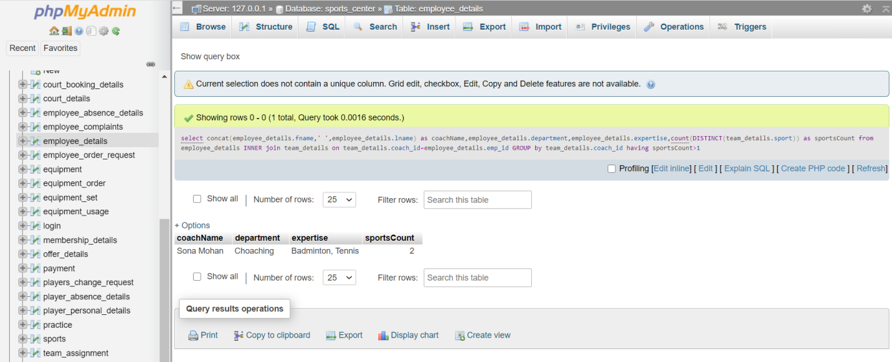

1. **Display details of employees and the leave details who are having more than 2 consecutive leave.**

select concat(employee\_details.fname,' ',employee\_details.lname) as empName,employee\_details.email,employee\_details.contact,employee\_details.department, DATEDIFF(employee\_absence\_details.absent\_to,employee\_absence\_details.absent\_from) as leaves from employee\_absence\_details INNER join employee\_details on employee\_absence\_details.emp\_id=employee\_details.emp\_id where DATEDIFF(employee\_absence\_details.absent\_to,employee\_absence\_details.absent\_from) >2

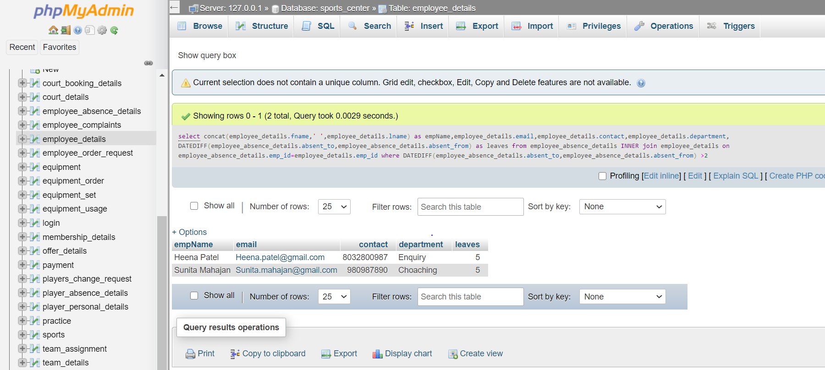

1. **Display the details of court, available time,date of available courts.**

select court\_booking\_details.\*,court\_details.court\_name from court\_booking\_details INNER join court\_details on court\_booking\_details.court\_id=court\_details.court\_id where court\_booking\_details.status = "Available"

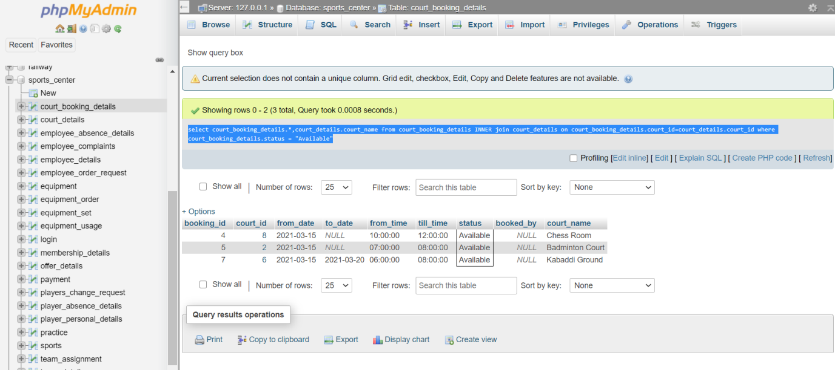

1. **Display the details of equipment which are currently available (I.e.not booked)**

select equipment.name,equipment\_set.sport\_name,equipment\_set.availabel\_set from equipment inner join equipment\_set on equipment\_set.set\_id = equipment.equipment\_set where equipment\_set.availabel\_set >0

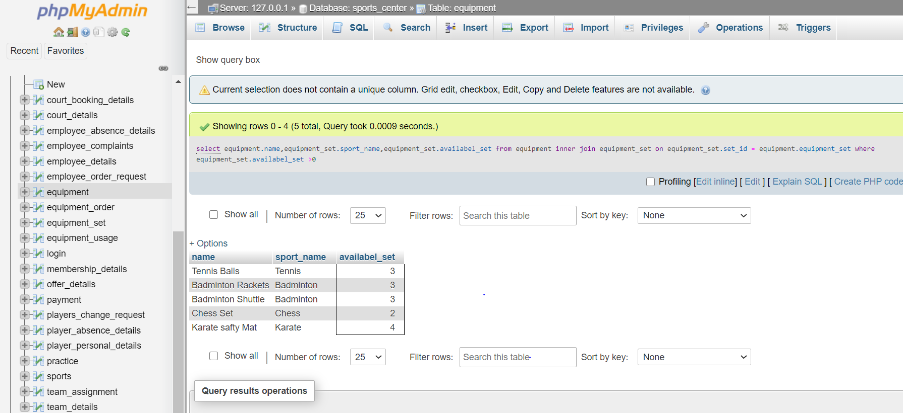

1. **Display the details of team who have practice in next week**

select practice.practice\_date,practice.from\_time,practice.till\_time, team\_details.team\_name,team\_details.sport, concat(employee\_details.fname,' ',employee\_details.lname) as coach from team\_details INNER join practice on team\_details.team\_id = practice.team\_id INNER join court\_booking\_details on practice.court\_booking\_id= court\_booking\_details.booking\_id INNER join employee\_details on court\_booking\_details.booked\_by=employee\_details.emp\_id where practice.practice\_date >=(AddDate(CURRENT\_DATE, interval 1 week))

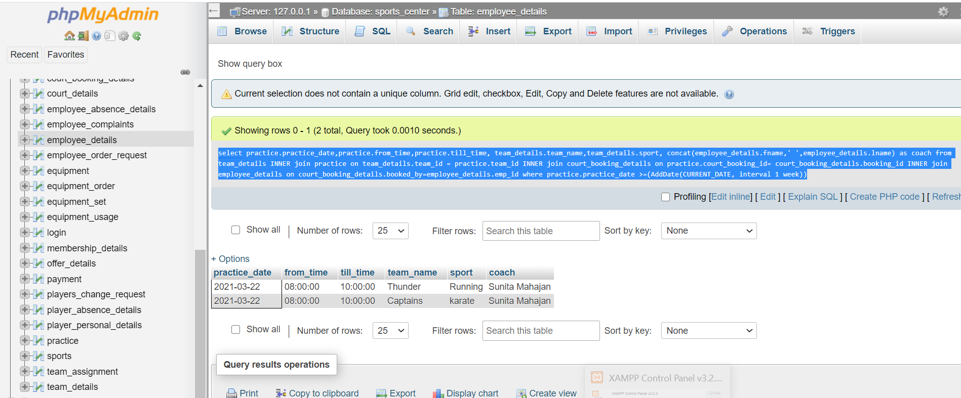

1. **Display the details of complaints which are currently open with assigned person’s name and their department**

[select](http://localhost/phpmyadmin/url.php?url=https://dev.mysql.com/doc/refman/5.5/en/select.html" \t "http://localhost/phpmyadmin/mysql_doc) employee\_complaints.complaint\_id,employee\_complaints.description,employee\_complaints.priority,employee\_complaints.created\_on,concat(employee\_details.fname,' ',employee\_details.lname) as assigned\_to, employee\_details.department from employee\_complaints INNER join employee\_details on employee\_complaints.assigned\_to=employee\_details.emp\_id where employee\_complaints.stauts [in](http://localhost/phpmyadmin/url.php?url=https://dev.mysql.com/doc/refman/5.5/en/comparison-operators.html" \l "function_in" \t "http://localhost/phpmyadmin/mysql_doc) ("Assigned","Created")

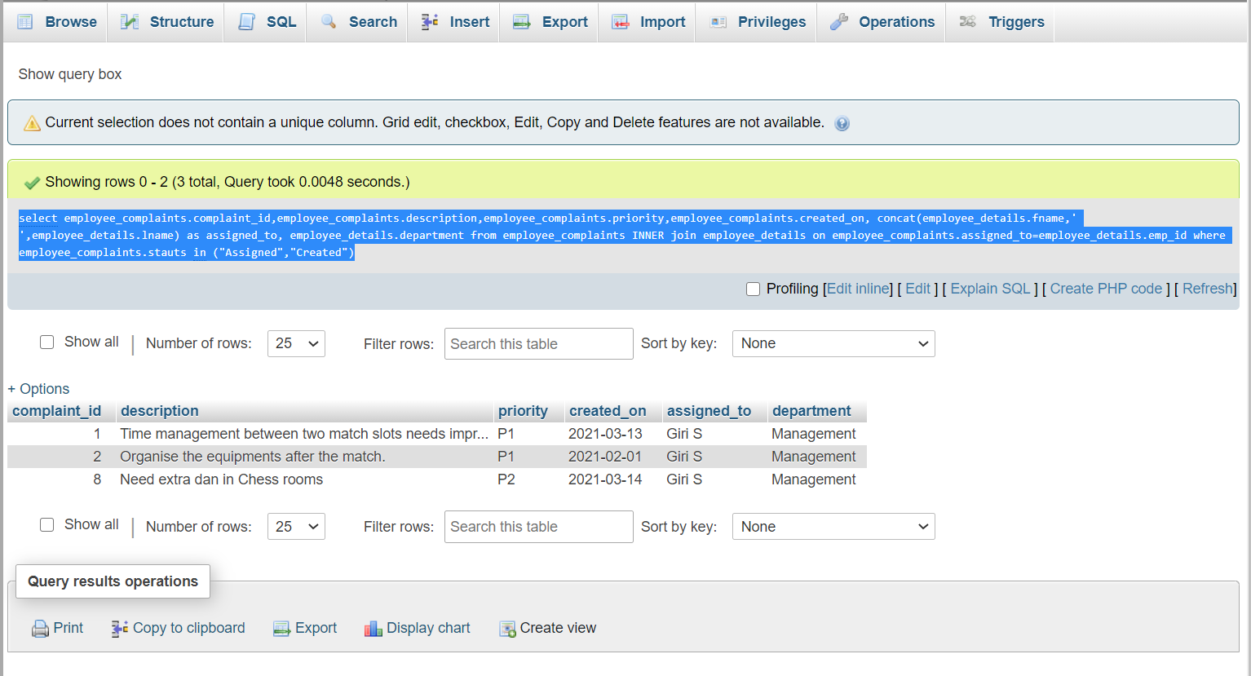

**15.Write the query for an employee to see complaints assigned to herself/himself**

[select](http://localhost/phpmyadmin/url.php?url=https://dev.mysql.com/doc/refman/5.5/en/select.html" \t "http://localhost/phpmyadmin/mysql_doc) employee\_complaints.complaint\_id,employee\_complaints.description,employee\_complaints.priority,employee\_complaints.stauts,employee\_complaints.created\_on, employee\_details.emp\_id, employee\_details.department from employee\_complaints INNER join employee\_details on employee\_complaints.assigned\_to=employee\_details.emp\_id where employee\_details.fname = "Heena" [and](http://localhost/phpmyadmin/url.php?url=https://dev.mysql.com/doc/refman/5.5/en/logical-operators.html" \l "operator_and" \t "http://localhost/phpmyadmin/mysql_doc) employee\_details.lname = "Patel"

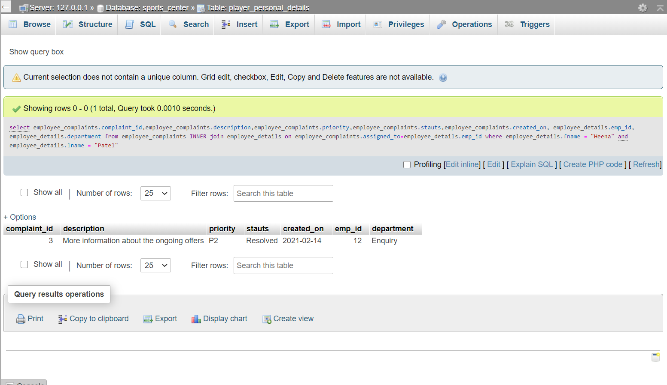

1. Display the details of player, it’s team, it’s coach name.

select concat(player\_personal\_details.fname,' ',player\_personal\_details.lname) as player\_name, player\_personal\_details.contact,concat(employee\_details.fname,' ',employee\_details.lname) as coach,team\_assignment.team\_id,

team\_details.team\_name,team\_details.sport from player\_personal\_details INNER join team\_assignment on team\_assignment.player\_id = player\_personal\_details.player\_id INNER join team\_details on team\_assignment.team\_id = team\_details.team\_id INNER join employee\_details on team\_details.coach\_id=employee\_details.emp\_id

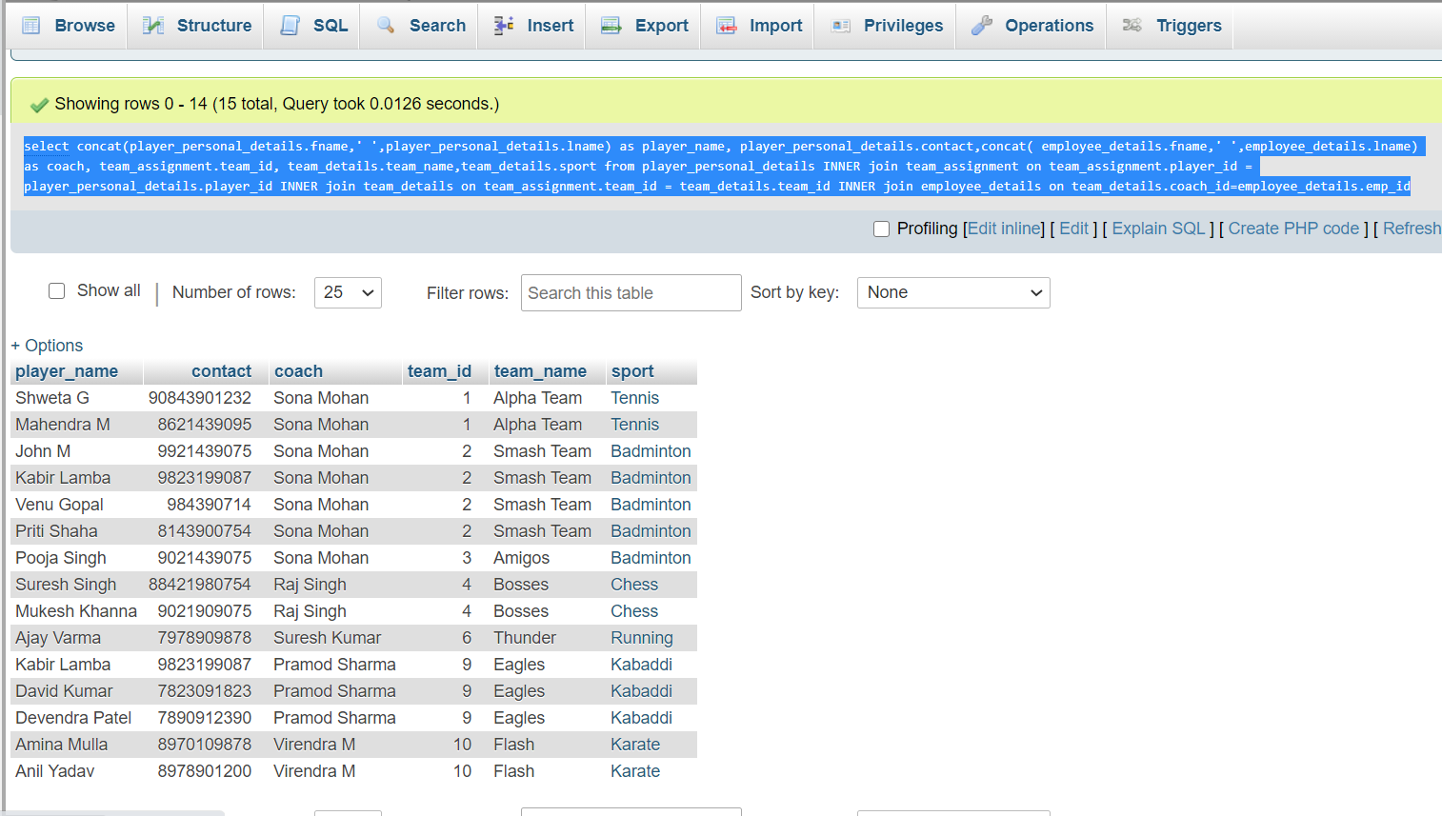

Bibliography

* [www.w3schools.com](http://www.w3schools.com)
* [www.Tutorialspoint.com](http://www.Tutorialspoint.com)